**CLOUD SERVER PROJECT**

ICT171

Introduction to Server Environments and Architectures

**MOHAMED SINAN**

**35078074**

Global IP address : 13.51.132.65

Domain**:** [https://store24.click](https://store24.click/" \t "_new)

**STEP1 : AMAZON EC2 (CHOSEN IAAS SERVER)**

1. Create an account in AWS
2. In the search bar, type EC2 and select EC2 Dashboard.
3. Click “Launch Instance”.
4. Chose Ubuntu Server 22.04 LTS (HVM), SSD Volume Type (Free tier eligible)
5. Selected **t2.micro** (1 vCPU, 1 GiB RAM) – Free Tier Eligible.
6. Created a new key pair and save it to computer for SSH access
7. Configure Network Settings (Security Group)

Created a new security group:

* + Allow SSH (Port 22) – for remote access.
  + Allow HTTP (Port 80) – for regular web traffic.
  + Allow HTTPS (Port 443) – for secure connections (SSL/TLS).
* Set the source to Anywhere (0.0.0.0/0) during development.

1. Assign and associate a public elastic IP to the instance.
2. 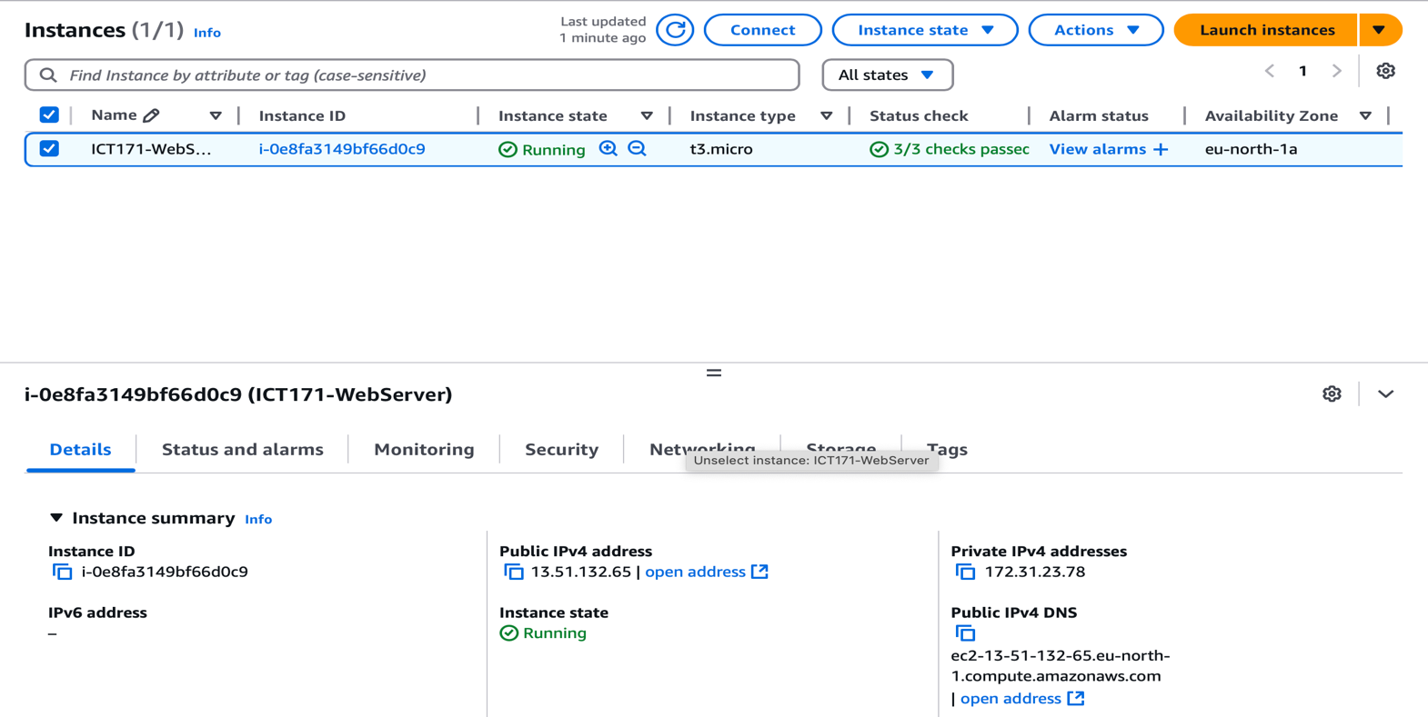Now the instance is running

STEP 2: Connect to AWS EC2 Server

**STEP 2: CONNECT TO THE CREATED INSTANCE**

1. Connect through PuTTY by entering public IP address and going to connection > SSH > Auth > Credentials here in the first box click on Browse and choose the converted KeyPair.

After giving these click “Open”, it will now ask for a username, usually for Amazon ec2, the username is “ec2-user”.

1. Install Apache

*sudo apt update*

*sudo apt install apache2 -y*

*sudo systemctl enable apache2*

*sudo systemctl start apache2*

**STEP 3 : DOMAIN NAME REGISTRATION AND DNS ENTRY**

1. Search Route 53 and find a domain. I bought store24.click for 3$.
2. Link the domain by creating a new record in hosted zones and adding record.
3. Add the public IP address of the instance and add record as shown in picture

4. also add www as alias so the site still opens when entered with www.

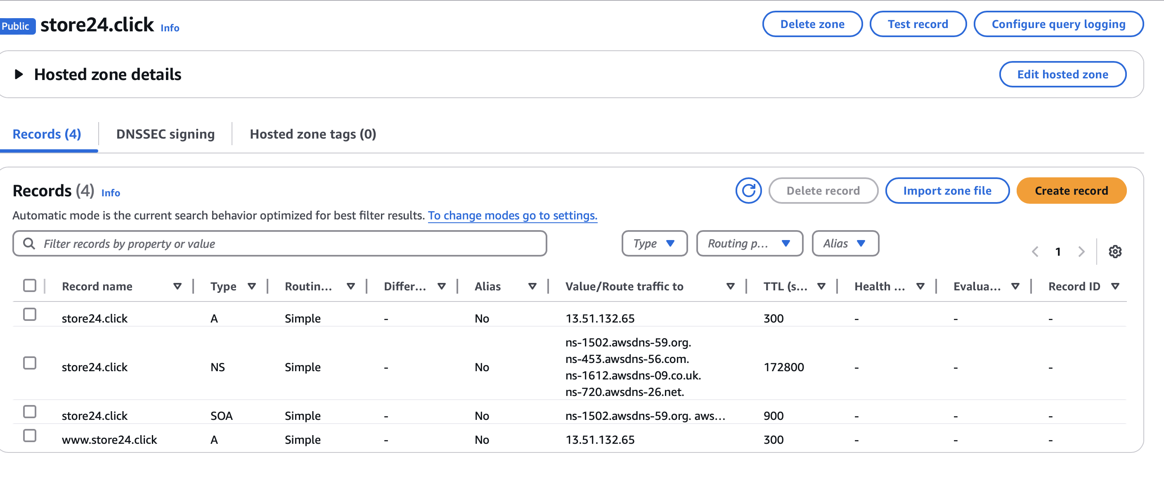

The site is now available by entering the domain.

**STEP 4: INSTALLING WORDPRESS ON EC2**

1. Connect to Instance
2. Install LAMP Stack (Apache, MySQL, PHP)

Run these commands:

sudo apt update

sudo apt install apache2 mysql-server php libapache2-mod-php php-mysql -y

### **Install WordPress**

cd /var/www/html

sudo wget https://wordpress.org/latest.tar.gz

sudo tar -xvzf latest.tar.gz

sudo mv wordpress/\* .

sudo rm -r wordpress latest.tar.gz

### **4. Set File Permissions**

sudo chown -R www-data:www-data /var/www/html

sudo chmod -R 755 /var/www/html

### **5. Create a MySQL Database for WordPress**

sudo mysql -u root -p

In MySQL, run:

CREATE DATABASE wordpress;

CREATE USER 'wpuser'@'localhost' IDENTIFIED BY 'yourpassword';

GRANT ALL PRIVILEGES ON wordpress.\* TO 'wpuser'@'localhost';

FLUSH PRIVILEGES;

EXIT;

### **6. Configure WordPress**

sudo cp wp-config-sample.php wp-config.php

sudo nano wp-config.php

Find this section and update it:

define('DB\_NAME', 'wordpress');

define('DB\_USER', 'wpuser');

define('DB\_PASSWORD', 'yourpassword');

define('DB\_HOST', 'localhost');

Save and exit

### **7. Restart Apache**

sudo systemctl restart apache2

**STEP 5: ACCESSING WORDPRESS SETUP WIZARD**

1. Open a browser and go to your **public domain** (e.g., http://store24.click or https://store24.click if SSL is enabled).
2. The**WordPress installation wizard**willappear**.**
3. Choose your language and click **Continue**.
4. Fill in your website details:

1. Click **Install WordPress**.
2. Once installed, click **Log In** to access the WordPress admin dashboard.

## **STEP 6: SETTING UP YOUR WEBSITE**

1. **Login** to the WordPress dashboard (<https://store24.click/wp-admin>).

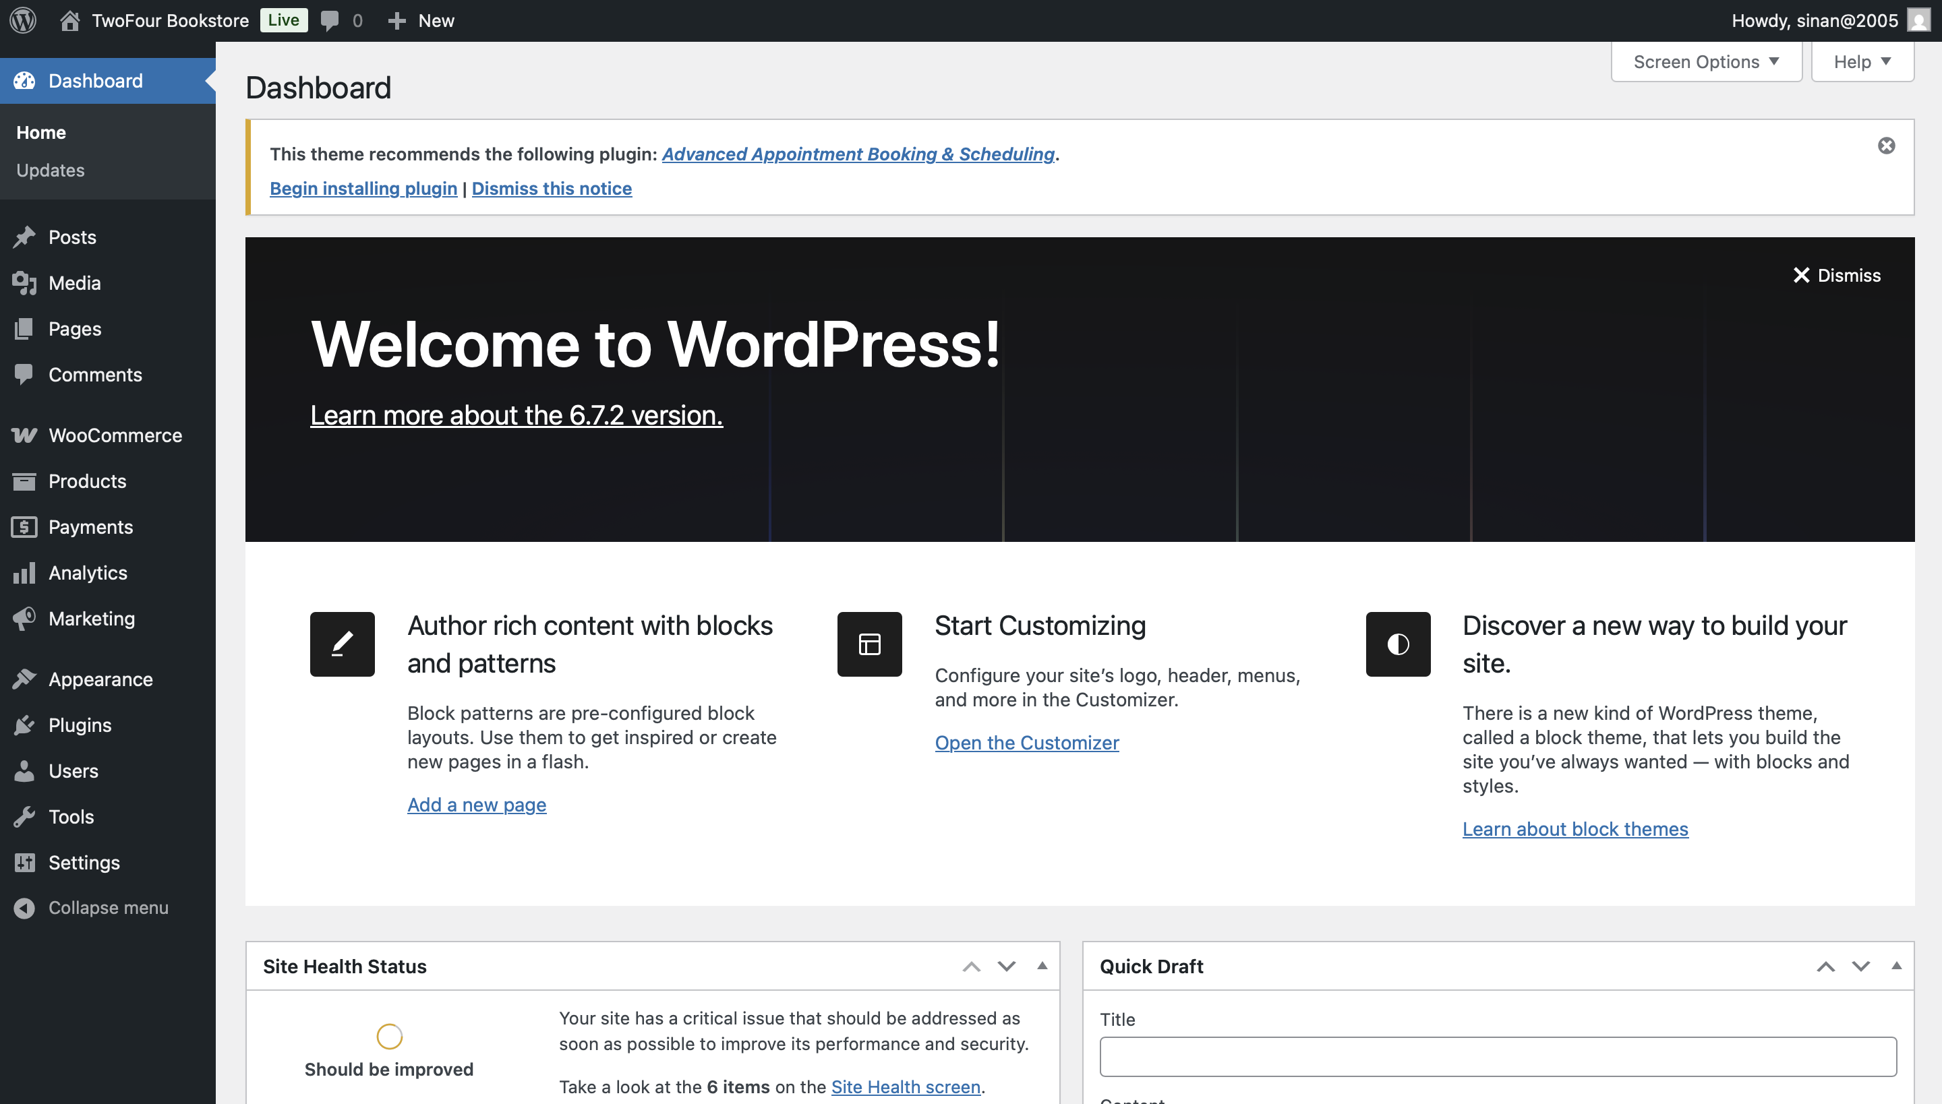

1. Go to **Appearance → Themes** and choose or install a theme (e.g., Astra, Storefront).
2. Go to **Plugins → Add New** and install the following:
   * **WooCommerce** (to manage products and shopping cart)
3. Configure WooCommerce (Currency, Payment, Shipping).
4. Add product categories (e.g., Novel, Fiction, Educational).
5. A screenshot of a computer

   Description automatically generatedGo to **Products → Add New** to list your bookstore items
6. Publish and go live
7. Go to settings -> reading and set static page as shop to ensure the shop shows up when the site is searched.

Now the site is up and running!

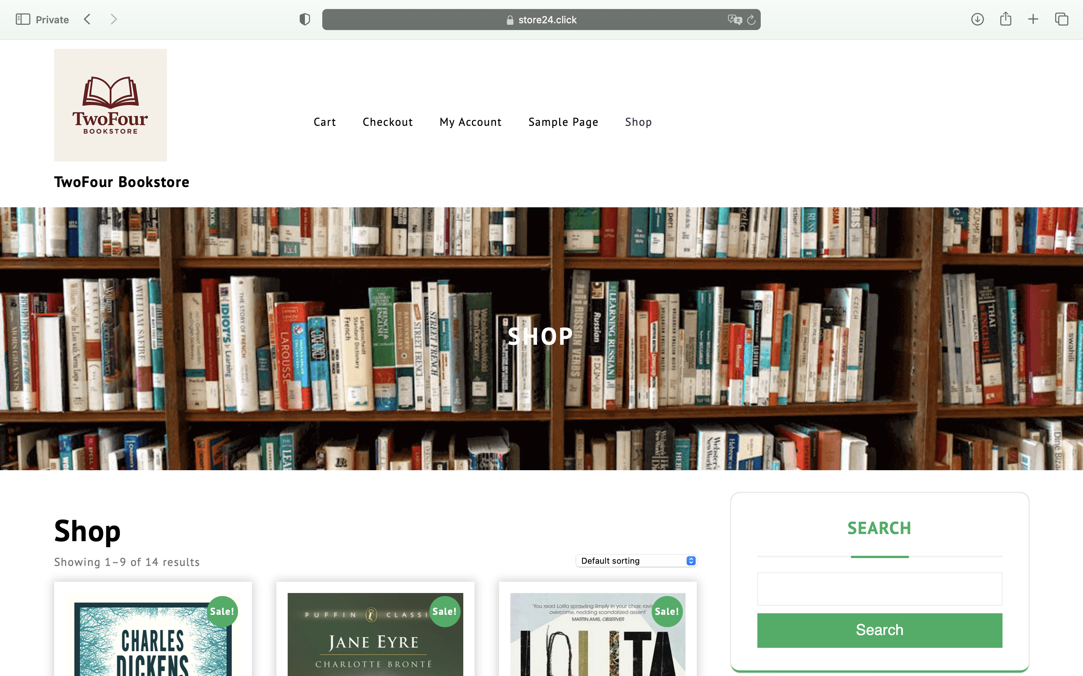

## **STEP 8: SECURING YOUR WEBSITE WITH SSL**

You used **Certbot** or **Let's Encrypt**to install SSL. The basic steps:

1. Install Certbot:

sudo apt install certbot python3-certbot-apache -y

1. Run Certbot:

sudo certbot --apache

1. Follow the prompts to enable HTTPS for store24.click.

The site is now secure and certified.

You can test SSL by visiting: <https://store24.click>

References:

1. <https://developer.wordpress.org/advanced-administration/before-install/howto-install/>
2. <https://docs.aws.amazon.com/ec2/>